**New Account Errors from Resident to Non-Resident:**

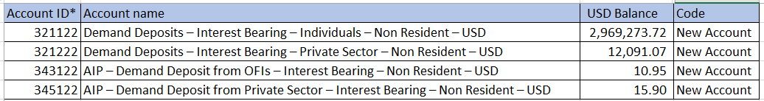

1. **321120-Demand Deposits – Interest Bearing – Individuals – Non Resident**

**Incorrect Line: 321120-Demand Deposits – Interest Bearing – Individuals – Non Resident**

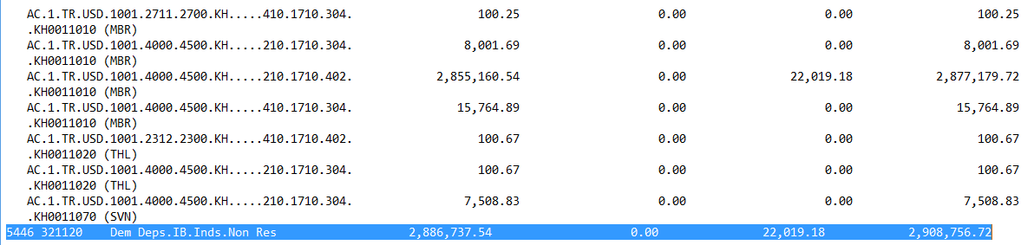

**Adjust to: 321110-Demand Deposits – Interest Bearing – Individuals –Resident**



Correct Line: 344110-AIP– Demand Deposit from Individuals – Interest Bearing

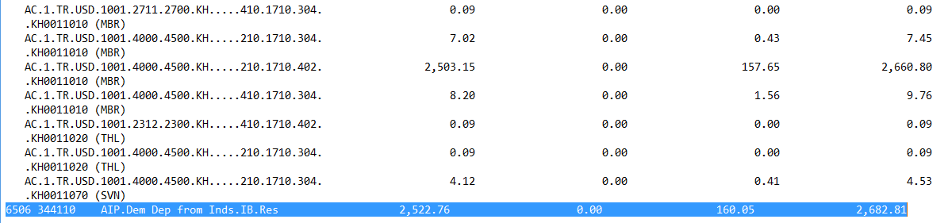

Correct Line: 621110-Interest Expenses – Demand Deposit from Individuals – Interest Bearing – Resident

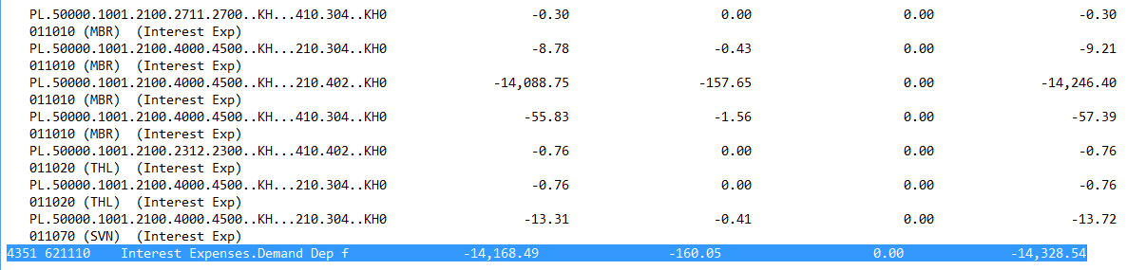

1. **321220-Demand Deposits – Interest Bearing – Private Sector – Non Resident**

**Incorrect Line: 321220-Demand Deposits – Interest Bearing – Private Sector – Non Resident**



Adjust to: 321210-Demand Deposits – Interest Bearing – Private Sector –Resident



**Incorrect Line: 345120-AIP – Demand Deposit from Private Sector – Interest Bearing – Non Resident**



Adjust to: 345110-AIP – Demand Deposit from Private Sector – Interest Bearing –Resident



**Correct Line: 621210-Interest Expenses – Demand Deposit from Private Sector – Interest Bearing – Resident**



1. **343120-AIP – Demand Deposit from OFIs – Interest Bearing – Non Resident**

**Correct Line: 311310-Demand Deposit – Interest Bearing from OFIs – Resident**



**Incorrect Line: 343120-AIP – Demand Deposit from OFIs – Interest Bearing – Non Resident**



Adjust to: 343110-AIP – Demand Deposit from OFIs – Interest Bearing –Resident



**Correct Line: 611310-Interest Expenses – Demand Deposit from OFIs – Interest Bearing – Resident**

